Sprint 3 Report
Last Revised:
(November 5, 2025 - November 16, 2025)

SlugConnect
Elian - product owner (e.g. product owner / developer)
Sam - Scrum Master
Tyler - Developer
Neha - Developer
Dean - Developer
Actions to Stop Doing
- The team needs to stop pushing the project to the side and dedicate time to work on the project and make progress
Actions to Start Doing
- The team can delegate responsibilities more and distribute the work load more evenly among the team members.

Actions to Keep Doing
- Full stack development for each team member ensuring all can work with frontend and backend

Work Completed / Not Completed
- Completed:
  - Ability to sign up using UCSC email
  - Search for other users
  - Various front-end components:
    - FilterSideBar
    - LoginCard
    - NavBar
    - OnboardingCard
    - ProfileCard
    - ProfileGrid
    - SearchBar
    - SignupCard
  - Pages that we can navigate to:
    - Signup
    - Onboarding
    - Connections
    - Discover
    - Profile
- Not Completed:
  - Authorization page route
  - Ability to log into account
  - Edit profile page
  - Filter profiles by information

Work Completion Rate
- 93.8%
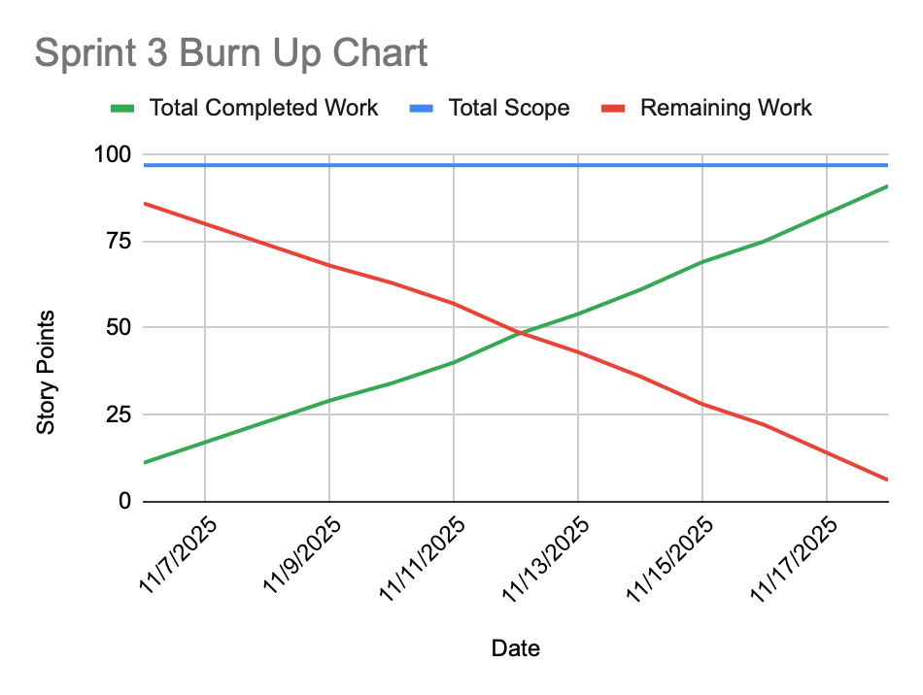
(Full Burn Up Chart spreadsheet is linked to graph)

